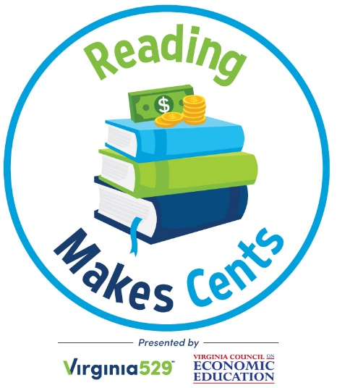

Elementary Librarians:

You’re invited to participate in Reading Makes Cents, a reading program for K-5 students that:
- earns you FREE books for your library.
- provides the opportunity to win $500 more worth of free books.
- assists you in teaching core SOL concepts through provided lesson plans.
- rewards your students for reading with the possibility of winning a Virginia529 savings account.

The Reading Makes Cents Reading Challenge helps K-5 students understand and apply many History and Social Science SOL concepts, including the ideas of scarcity, decision-making, work, money, and saving.

These financial literacy lessons will benefit your students – the sooner they learn about saving and managing money, the more financial success they may find in the future.

For participating in Reading Makes Cents, your library will receive the following books with library binding for FREE:

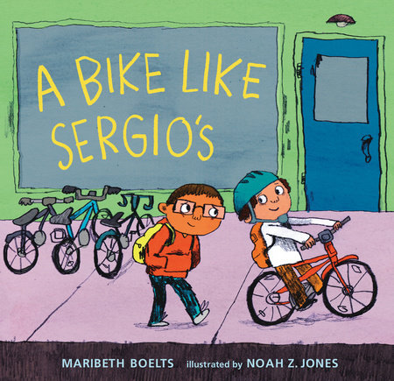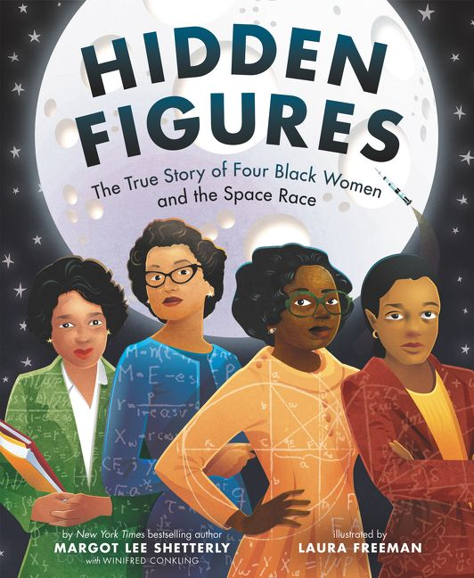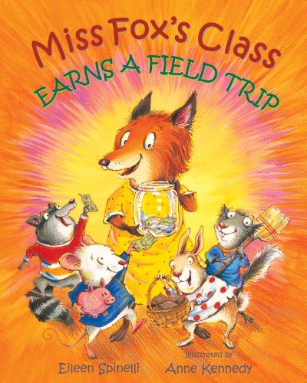
A Bike Like Sergio’s Hidden Figures Miss Fox’s Class Earns a Field Trip
Maribeth Boelts Margot Lee Shetterly Eileen Spinelli

PRIZES:

Fourteen student participants (two from each of the seven VaASL regions) will be randomly selected to win $529 Virginia529 higher education savings accounts.

The seven schools (one from each VaASL region) with the highest student participation on a percentage basis will receive $500 worth of financial literacy books for their school library.

Sign up today using this application or register online at www.ReadingMakesCents.com.

See website for official terms and conditions.
By signing up to receive free books, you agree to do the following:

- Read and discuss the featured books with students in at least one grade level. Lesson plans and activities are available at www.ReadingMakesCents.com.

- Provide the Reading Makes Cents Reading Challenge handout to your students.
- To be eligible for the $529 account drawings, participating students must read (or have read to him/her) at least five books from the list of more than 60 titles.
- Students must then submit their completed Reading Challenge handout (complete with a parent’s information and signature) to Virginia529.
  - TIP: Librarians can collect all Reading Challenges from students and mail them in bulk to Virginia529.
- Entries must be sent/postmarked by April 12, 2019.
- From a drawing of all entries, two students in each region – a total of 14 winners – will be selected to receive an Invest529 account with an initial balance of $529.
- Winners will be announced on or about May 10, 2019.

- Promote the Reading Makes Cents program. This can be done in a variety of ways. Distribute information to parents and teachers, publish an article in the community newspaper, make a bulletin board, hold a competition, or use another strategy to generate excitement.

- Complete the post-program evaluation by April 26, 2019, to report on your school’s participation. Submitting the evaluation is a requirement for eligibility for the $500 book prize. Failure to complete the evaluation may exclude your school from receiving free books through the Reading Makes Cents program next year.

YES. My school would like to participate in Reading Makes Cents. We will read the featured books to at least one grade level and promote the program.

Note: Only one set of books will be provided to each elementary school.

Please mail the books for my school library to:

First name: ______________________________________________________________________
Last name: ______________________________________________________________________
School division: __________________________________________________________________
School: _________________________________________________________________________
Mailing address: __________________________________________________________________
City: ____________________________________________________________________________
ZIP code: ________________________________________________________________________
Phone number: ____________________________________________________________________
Email address: ____________________________________________________________________

Submit this completed form using any of the following methods:

Mail: Virginia529 ATTN: Reading Program
9001 Arboretum Parkway
North Chesterfield, VA 23236
Email: readingmakescents@virginia529.com
Fax: 804-323-2708
OR complete and submit the form online at www.ReadingMakesCents.com.

Virginia529 collects personal data in accordance with its Privacy Policy, available at Virginia529.com.

Special thanks to the Virginia Association of School Librarians for their valuable input in shaping this program.

Thank you for your help in promoting financial literacy across Virginia!

